Test Cases Overview
This document presents a comprehensive and well-structured set of test cases designed to verify the functionality of the Dental Clinic System. The test cases cover the main system features, including user registration, login, role-based access, and core operations for patients, doctors, and receptionists.
Each test case includes a clear description, test steps, expected results, and actual results, supported by screenshots where applicable. The goal of this testing process is to ensure that the system behaves correctly, validates user input properly, and meets the specified functional requirements.

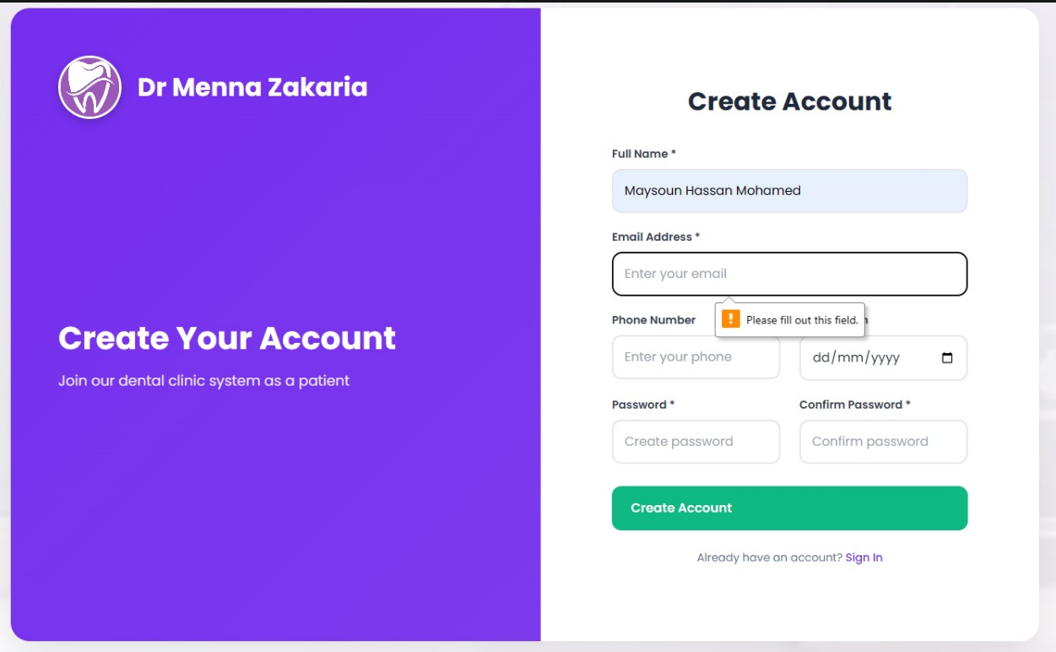Test Case ID
TC-01
Title
Sign Up – Email Field Required Validation
Actor
User
Description
This test case ensures that the system does not allow a user to create an account without entering an email address and shows an appropriate validation message.
Preconditions
- The user is on the Sign-Up page.
Test Steps
- Open the Sign-Up page.
- Enter all required information except the email address.
- Click the Create Account button.
Expected Result
- The account is not created.
- An error message appears indicating that the email field is required.
Actual Result
The system displays a message asking the user to enter an email address.
Status
Pass
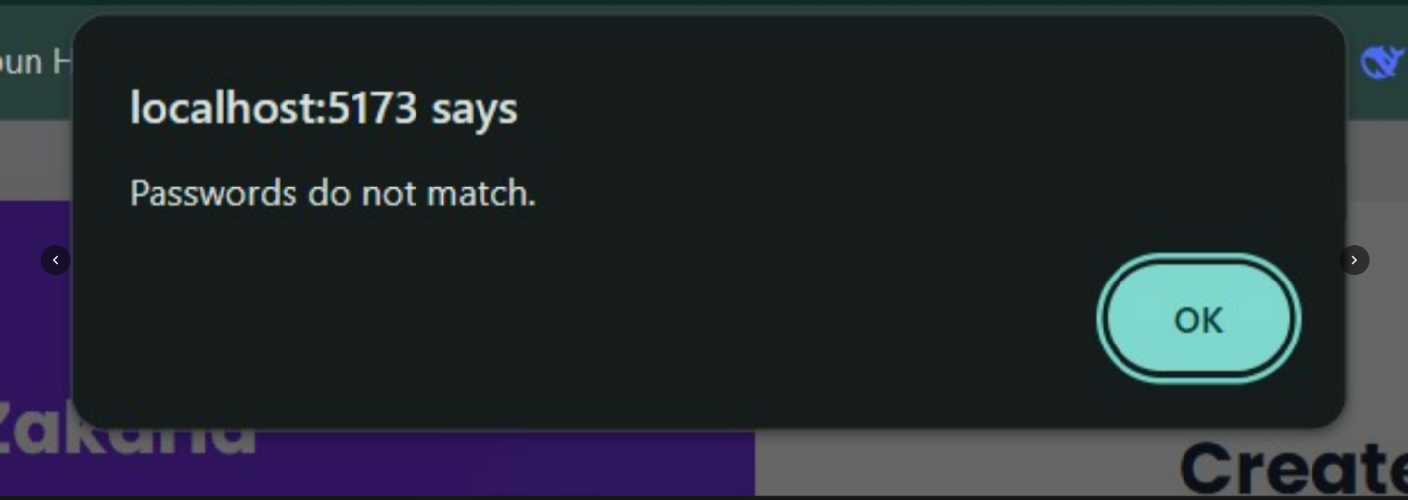Test Case ID
TC-02
Title
Sign Up – Password Mismatch Validation
Actor
User
Description
This test case verifies that the system displays a warning message when the password and confirm password fields do not match during the sign-up process.
Preconditions
- The user is on the Sign-Up page.
Test Steps
- Open the Sign-Up page.
- Enter all required information.
- Enter a password in the Password field.
- Enter a different password in the Confirm Password field.
- Click the Create Account button.
Expected Result
- The account is not created.
- A warning message is displayed indicating that the passwords do not match.
Actual Result
The system displays a warning message stating that the passwords do not match.
Status
Pass

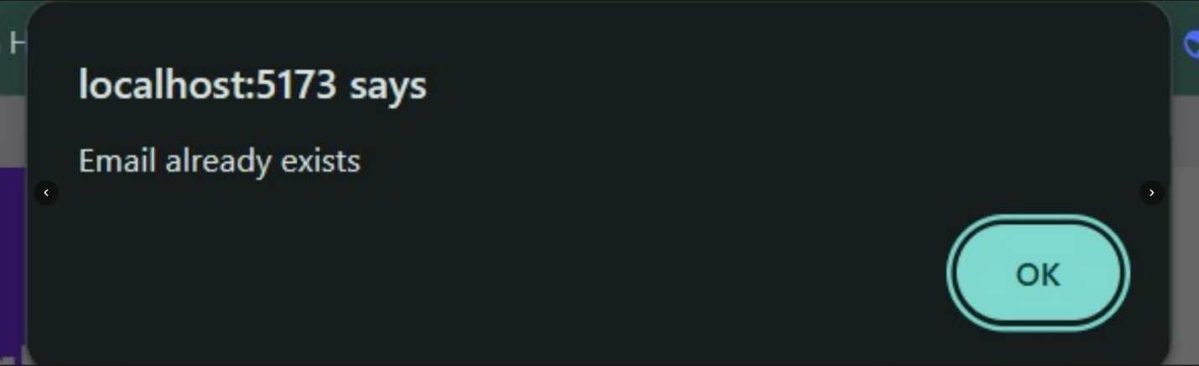Test Case ID
TC-03
Title
Sign Up – Existing Email Validation
Actor
User
Description
This test case verifies that the system displays a warning message when a user attempts to sign up using an email address that already exists in the system.
Preconditions
- The user is on the Sign-Up page.
- The email address is already registered in the system.
Test Steps
- Open the Sign-Up page.
- Enter all required information.
- Enter an email address that already exists.
- Click the Create Account button.
Expected Result
- The account is not created.
- A warning message is displayed indicating that the email already exists.
Actual Result
The system displays a warning message stating that the email already exists.
Status
Pass

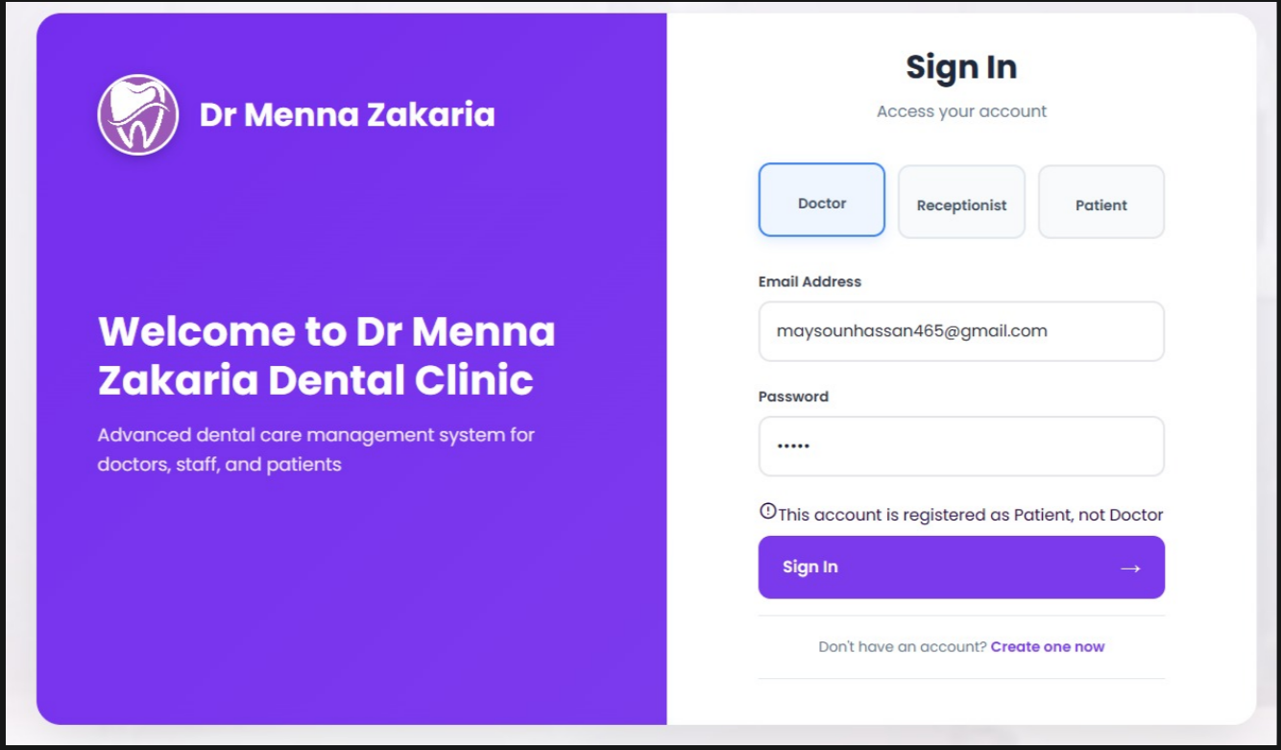Test Case ID
TC-04
Title
Login – Role Mismatch Validation
Actor
User
Description
This test case verifies that the system displays an appropriate message when a user attempts to log in with a role different from the role registered for the account.
Preconditions
- The user has a registered account with the role Patient.
- The user is on the Login page.
Test Steps
- Open the Login page.
- Enter valid email and password.
- Select Doctor as the role.
- Click the Login button.
Expected Result
- The user is not logged in.
- A message is displayed indicating that the account is registered as Patient, not Doctor.
Actual Result
The system displays a message informing the user that the account is registered as Patient and not Doctor.
Status
Pass
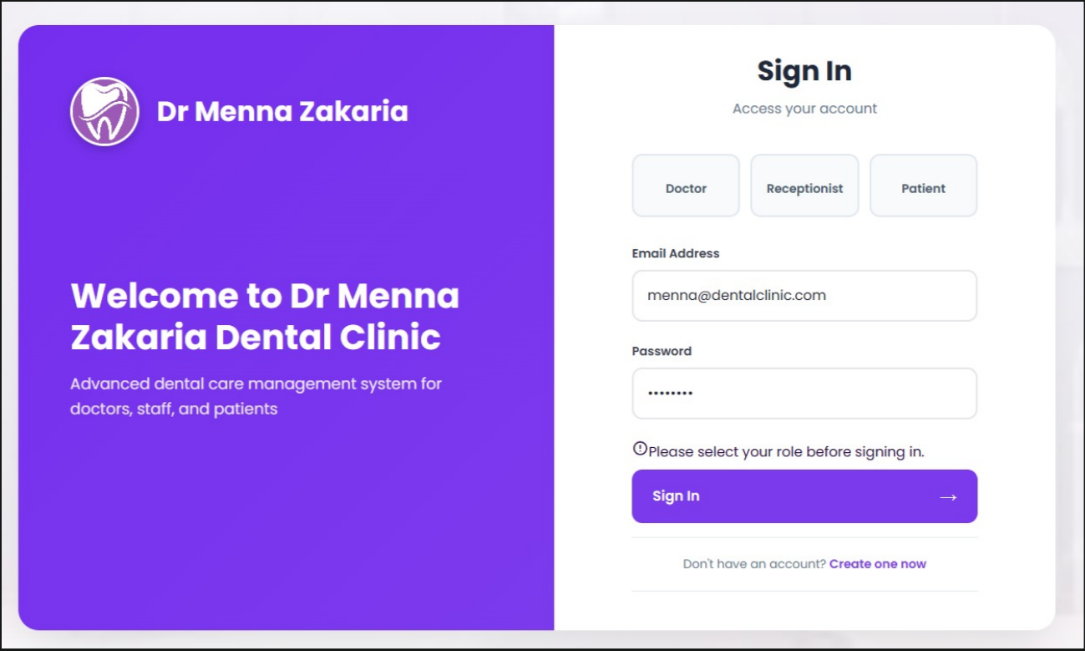Test Case ID
TC-05
Title
Login – Role Selection Required Validation
Actor
User
Description
This test case verifies that the system displays an error message when a user attempts to log in without selecting a role.
Preconditions
- The user is on the Login page.
Test Steps
- Open the Login page.
- Enter a valid email and password.
- Do not select any role.
- Click the Login button.
Expected Result
- The user is not logged in.
- An error message is displayed indicating that selecting a role is required.
Actual Result
The system displays a message asking the user to select a role.
Status
Pass
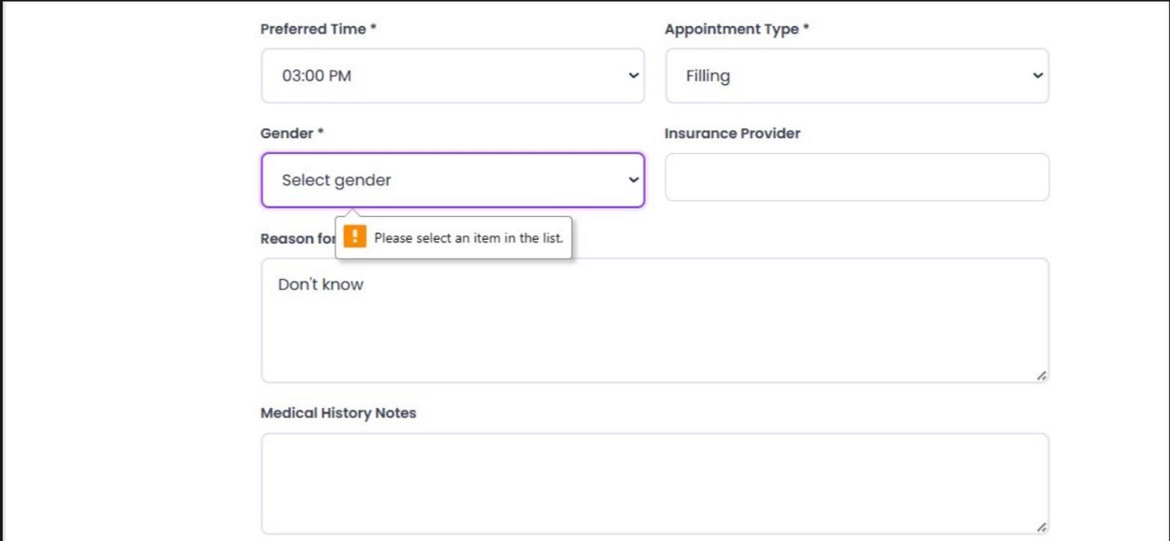Test Case ID
TC-06
Title
Appointment – Gender Selection Required Validation
Actor
Patient
Description
This test case verifies that the system displays an error message when a patient tries to book an appointment without selecting their gender.
Preconditions
- The patient is logged in.
- The patient is on the Book Appointment page.
Test Steps
- Open the Book Appointment page.
- Fill in all required information except the Gender field.
- Click the Submit / Book Appointment button.
Expected Result
- The appointment is not booked.
- An error message is displayed indicating that selecting gender is required.
Actual Result
The system displays a message asking the user to select their gender.
Status
Pass

